COAL Lab 1
Task 1: (1)
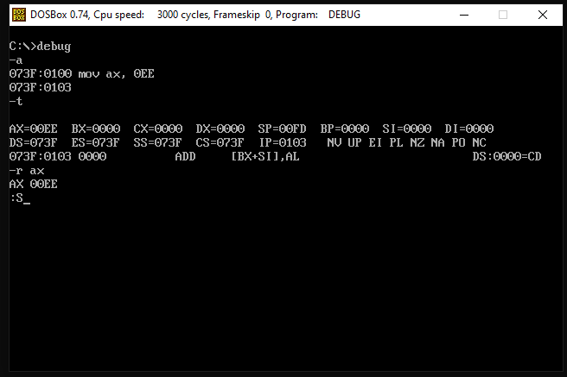

Task 1: (2)
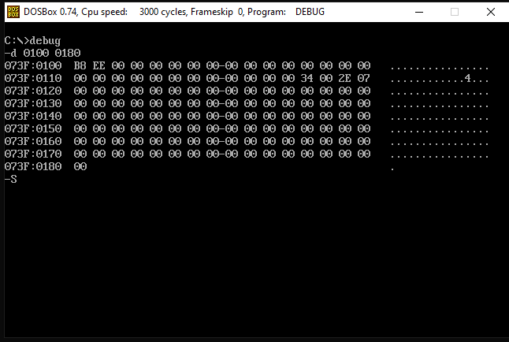

Task 1: (3)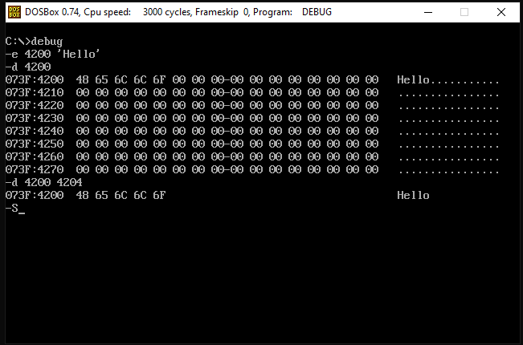
Task 1: (4)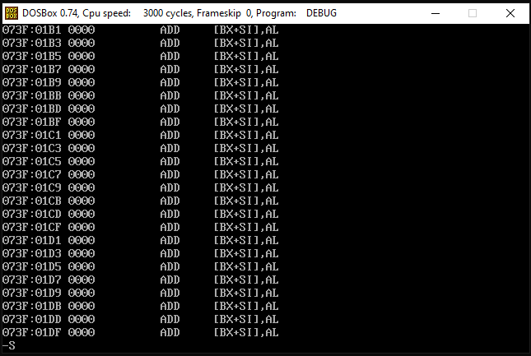
Display the code of Segment CS from offset 100 to 1E0
Task 1: (5)
Code Segment Register refers to code
Task 1: (6)
Quit q is used to exit from debugger

Task 2:
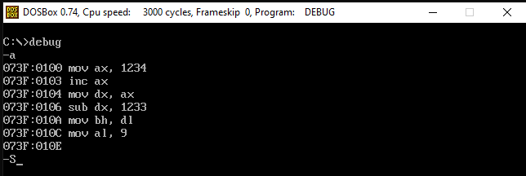
Task 3:
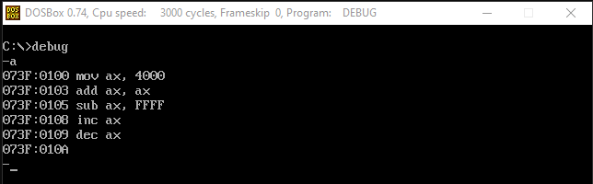

Task 4:
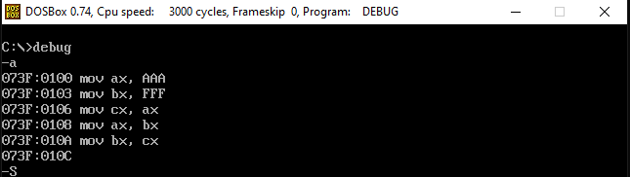
Task 5: (1)
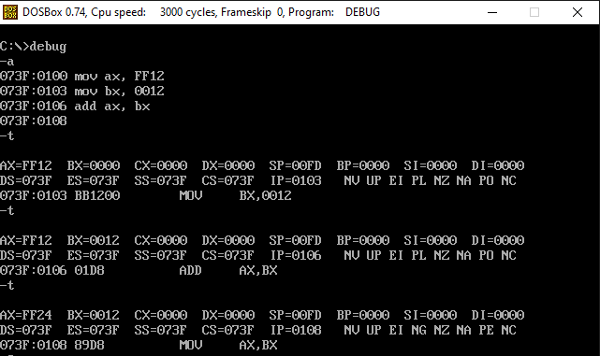
Task 5: (2)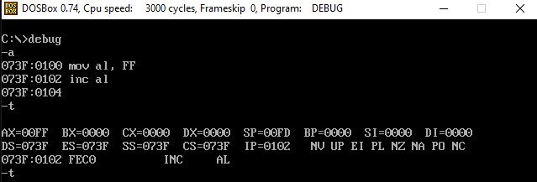
Task 5: (3)
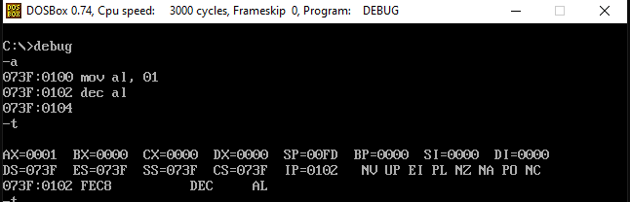
Task 5: (4)
